Name

Mathematics Advanced Year 11
Constructing and Using Functions

Book 1 |  | Version: 261007  Feedback:  https://MrDingMaths.com
Contents
Syllabus Content 2
Learning Intention 3

Syllabus Content
MAV-11-02 uses functions and relations to model, analyse and solve problems
Constructing and using functions
- Construct and use linear functions to model and solve problems in real-world situations, identifying the independent and dependent variables and any restrictions on these variables, and justify conclusions in the context of the problem
- Use linear inequalities to model and solve problems in real-world situations, and justify conclusions in the context of the problem
- Solve practical problems involving a pair of simultaneous linear equations both algebraically and graphically, with and without graphing applications, and justify conclusions in the context of the problem
- Construct and use simultaneous equations to model and solve a problem where cost and revenue are represented by linear equations, identify and analyse the break-even point, and justify conclusions in the context of the problem
- Model and solve practical problems involving quadratic functions and justify conclusions in the context of the problem

Linear Modelling

- Interpreting Linear Models
Linear relationships model many real-life scenarios.
The gradient is the rate; it represents the change in $y$ per unit increase in $x$.
The $y$-intercept is the initial or fixed value at $x=0$.

- Interpret the gradient and $y$-intercept of a linear model
Identify the meaning of the gradient and $y$-intercept of these linear models.
- Taxi hire cost  Gradient: 2  Meaning: 2 …………… per ……………  $y$-intercept: 10  Meaning: …… for … …………  Equation relating $C$ and $t$:  $$y=mx+c$$  …… $=$ … … $+$ … | 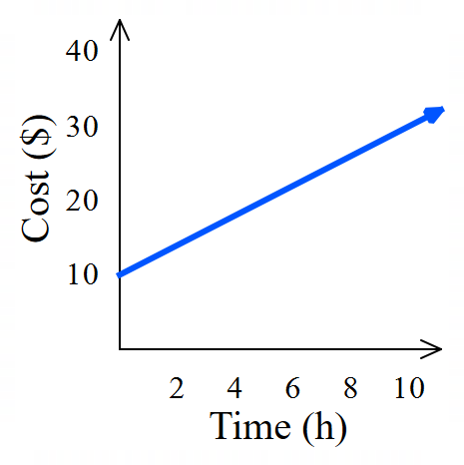  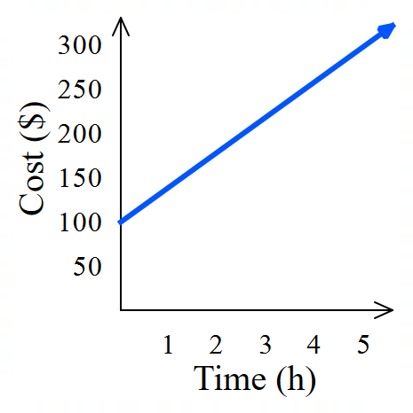  - Plumber hire cost  Gradient: 40  Meaning: ………………………………………  $y$-intercept: 100  Meaning: ………………………………………  Equation relating $C$ and $t$:  $$y=mx+c$$  …… $=$ … … $+$ …
- Volume of water in a tank  Gradient: $-75$  Meaning: ………………………………………  $y$-intercept: 1000  Meaning: ………………………………………  Equation relating $V$ and $t$: | 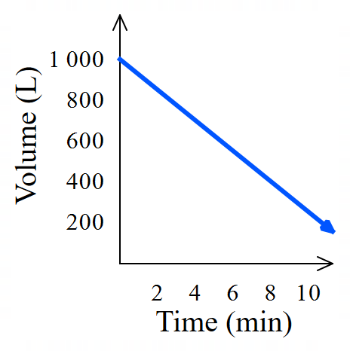  - Population of Australia  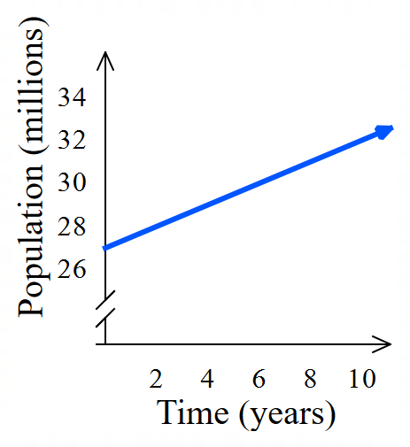  Gradient: $0.5$  Meaning: ………………………………………  $y$-intercept: 27  Meaning: ………………………………………  Equation relating $P$ and $t$:

Foundation
- Identify what the gradient and $y$-intercepts of these graphs represent, then write the equation.
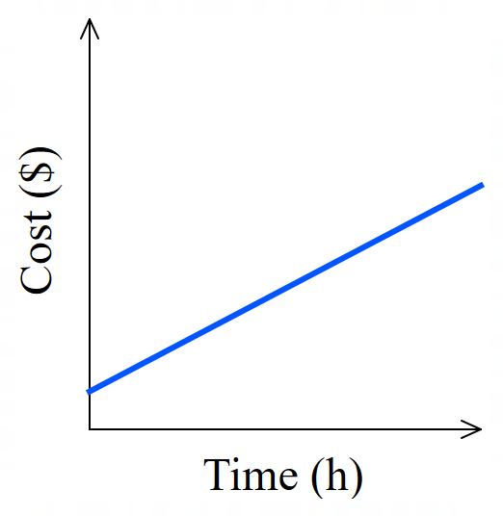  Gradient: 0.5  Meaning:  0.5 …………………… per ……………………  0.5 dollars per hour  $y$-intercept: 2  Meaning:  ……………………………………………………  $2 for 0 hours (initial cost)  Equation relating cost $C$ and time $t$:  $$y=mx+c$$  …… $=$ … … $+$ …  $$C=0.5t+2$$ | 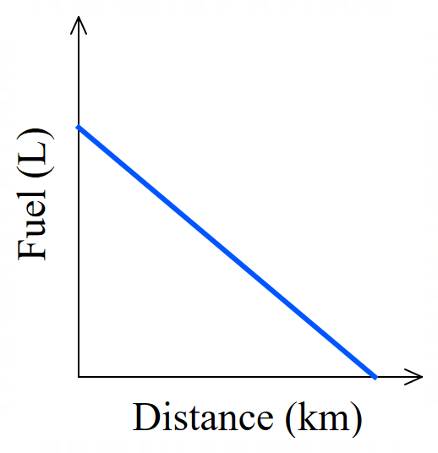  Gradient: $-0.8$  Meaning:  $-0.8$ L per km  $y$-intercept: 15  Meaning:  15 L at 0 km (initial volume)  Equation relating fuel $f$ and distance $d$:  $$y=mx+c$$  …… $=$ … … $+$ …  $$f=-0.8d+15$$
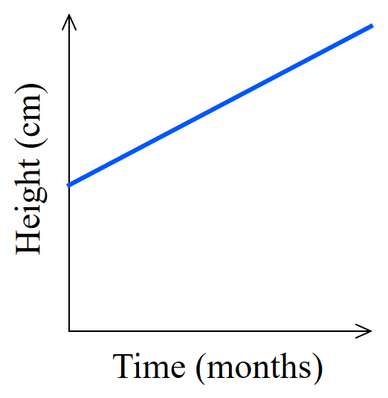  Gradient: 2.5  Meaning:  2.5 cm per month  $y$-intercept: 50  Meaning:  50 cm at 0 months (initial height)  Equation relating height $h$ and time $t$:  $$h=2.5t+50$$ | 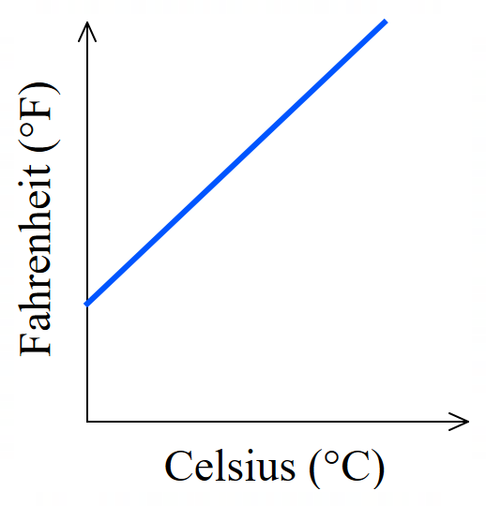  Gradient: 1.8  Meaning:  $$1.8 °F per 1°C$$  $y$-intercept: 32  Meaning:  $32°F$ at $0°C$  Equation relating $F$ and $C$:  $$F=1.8C+32$$

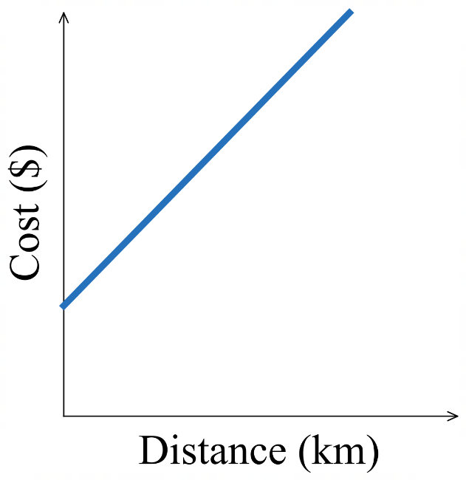  Gradient: 3  Meaning:  3 dollars per km  $y$-intercept: 5  Meaning:  $5 for 0 km (initial cost)  Equation relating cost $C$ and distance $d$:  $$C=3d+5$$ | 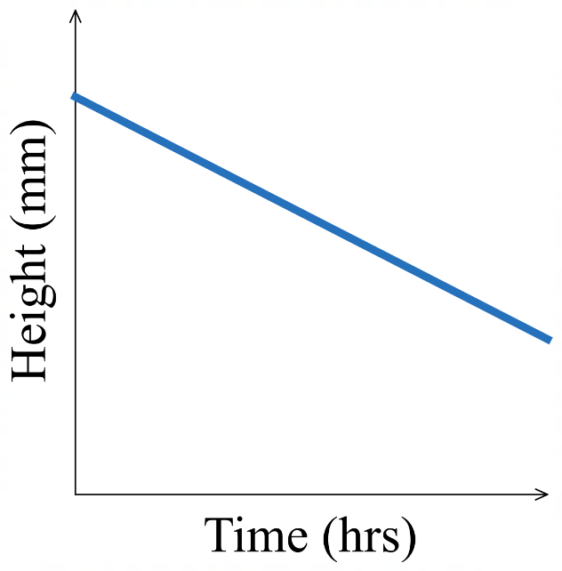  Gradient: $-10$  Meaning:  $-10$ mm per hr  $y$-intercept: 80  Meaning:  80 mm at 0 hrs (initial height)  Equation relating height $h$ and time $t$:  $$h=-10t+80$$
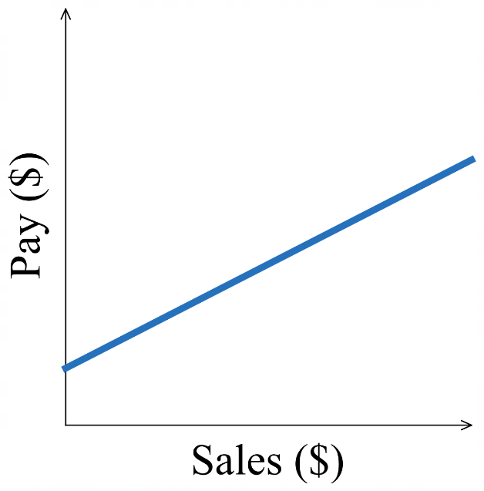  Gradient: 0.1  Meaning:  $0.10 pay per dollar sales  $y$-intercept: 300  Meaning:  $300 pay for $0 sales (initial pay, or retainer)  Equation relating pay $P$ and sales $s$:  $$P=0.1s+300$$ | 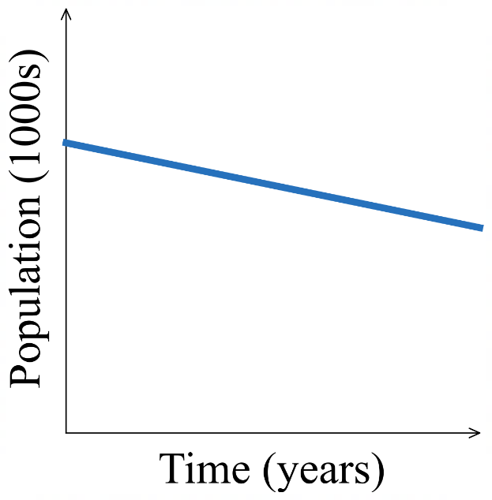  Gradient: $-2$  Meaning:  $-2000$ people per year  $y$-intercept: 50  Meaning:  $50 000$ people at 0 years (initial population)  Equation relating $P$ and $t$:  $$P=-2t+50$$

- Example Interpret a linear model
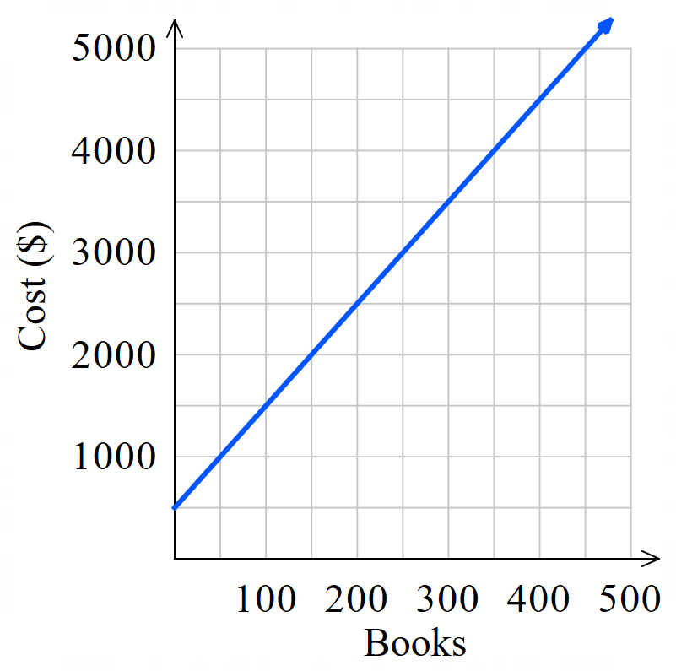
The linear model shows the cost of setting up a book printing business.
  - Find the cost of printing 400 books.
$4500
  - Find the number of books that can be printed for
$3000.
250 books
  - Find the $y$-intercept. What is its meaning?
$500.
This is the fixed cost for setting up the printing.

  - Find the gradient of the line, what is its meaning?
By choosing (0,500) and (400, 4500):
$$m=\frac{cost}{books}=\frac{4000}{400}=10$$
cost per book is $10.
  - Write an equation relating cost $C$ and number of books $n$.
$m=10, c=500$ $C=10n+500$

- Guided Practice
The linear model shows the volume of a chemical tank over time.
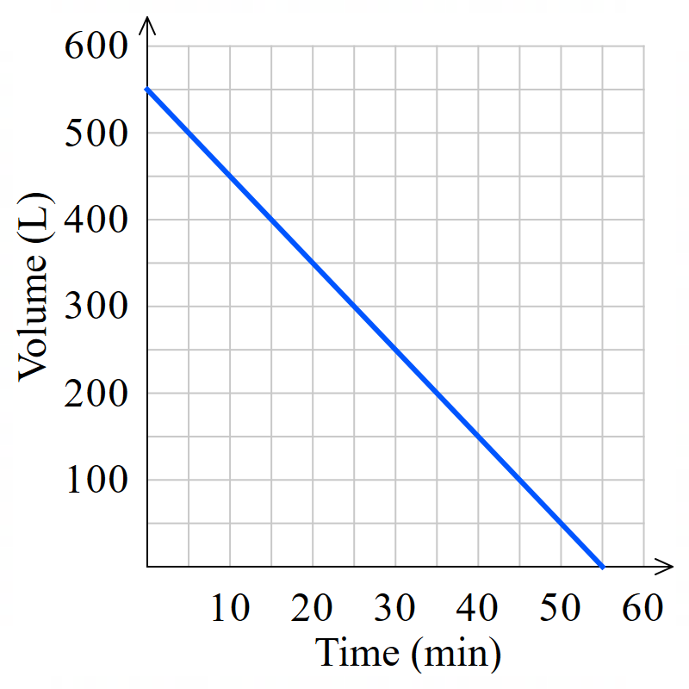
- Find the volume after 30 minutes.

250 L
- When is the volume 200 L?

35 minutes
- Find the $y$-intercept. What is its meaning?

550 L; Initial volume.
- Find the gradient of the line, what is its meaning?

$-10$ litres per minute
- Write an equation relating volume $V$ and time $t.$

$$V=-10t+550$$
- Linear Modelling
- Read the scenario in its entirety. Highlight the variables and the numbers.
- Identify the dependent variable $y$. It changes based on another variable.
- Identify the independent variable $x$. It causes the change.
- Determine the gradient $m.$ This is the rate given by the question. “$m$ per $x$”
- Determine the $y$-intercept $c$. This is the initial or fixed value given by the question.
Rate of change; $m$ per $x$
Initial or fixed value at $x=0$
Dependent variable
Independent variable
$$y=mx+c$$

- Example Construct a linear model from a given scenario
A muffin shop has fixed costs of $100 a day and a production cost of $1.50 per muffin.
Write an equation relating cost $C$ and number of muffins $n$.
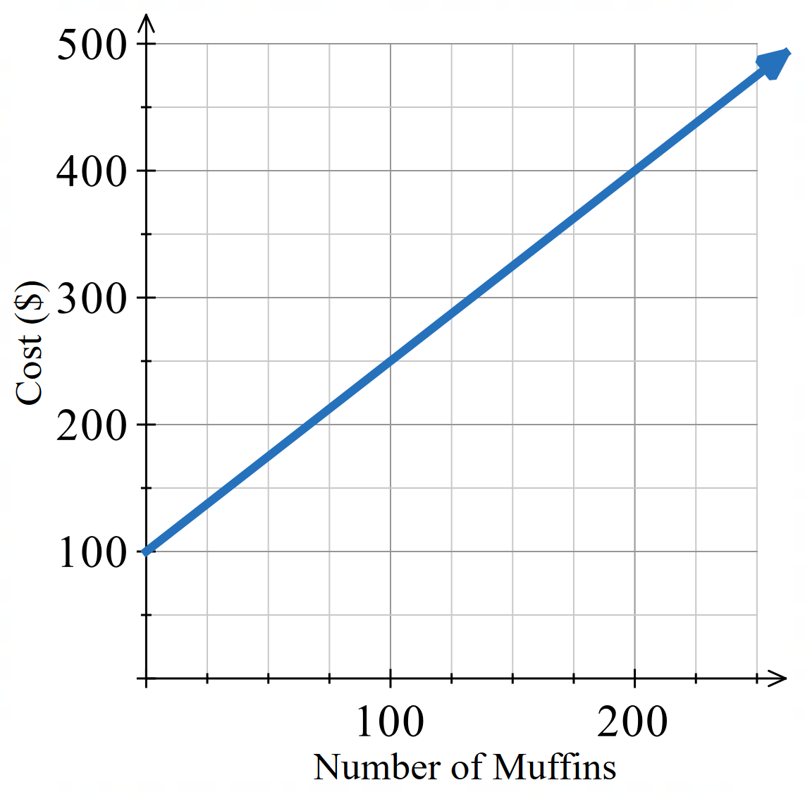
Dependent var: Cost $C$
Independent var: Number of muffins $n$
Variable cost $m=1.5$
Fixed cost $c=100$
$y=mx+c$
$C=1.5n+100$

Use your equation to determine the number of
Muffins that can be produced for $300.
$300=1.5n+100$
$200=1.5n$
$$\frac{200}{1.5}=n$$
$$133≈n$$

- Guided Practice
- Mr Ding has a soft toy factory that has a fixed cost of $500 a day and a production cost of $2 per soft toy.
Write an equation relating cost $C$ and number of soft toys $n$.
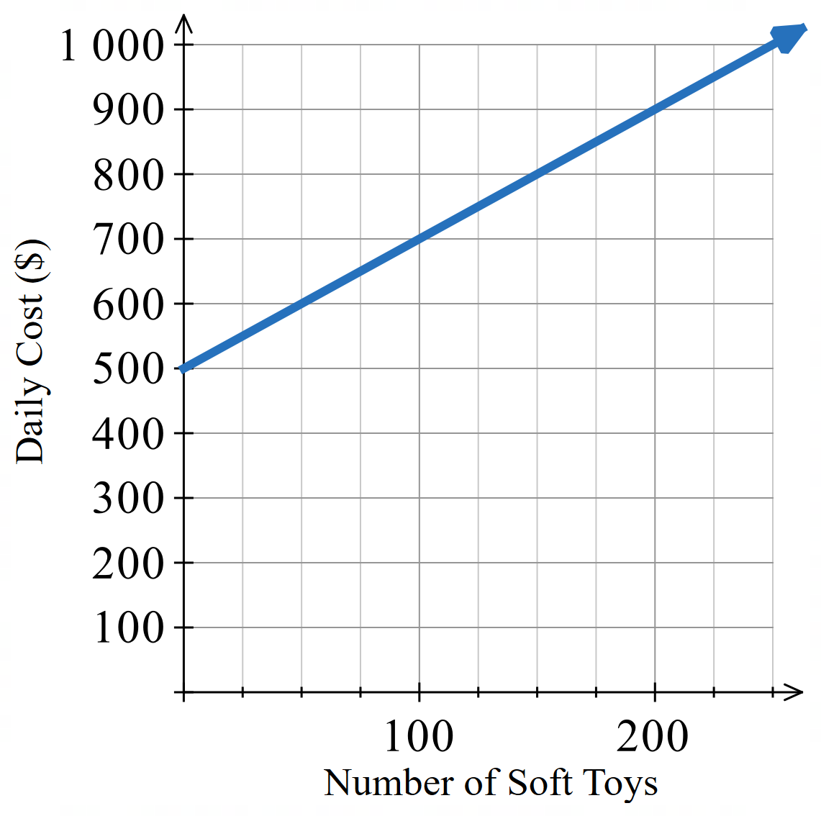

$$C=2x+500$$
Use your equation to determine how many soft
toys he can produce with a daily budget of $800.
How does this compare with the graph?

150
- Mr Ding is converting Australian Dollars ($AUD) to Japanese Yen (¥JPY)
$0 buys ¥0. For each $1, he can buy ¥110.
Write an equation relating Australian dollars $D$ and Japanese Yen $Y$.
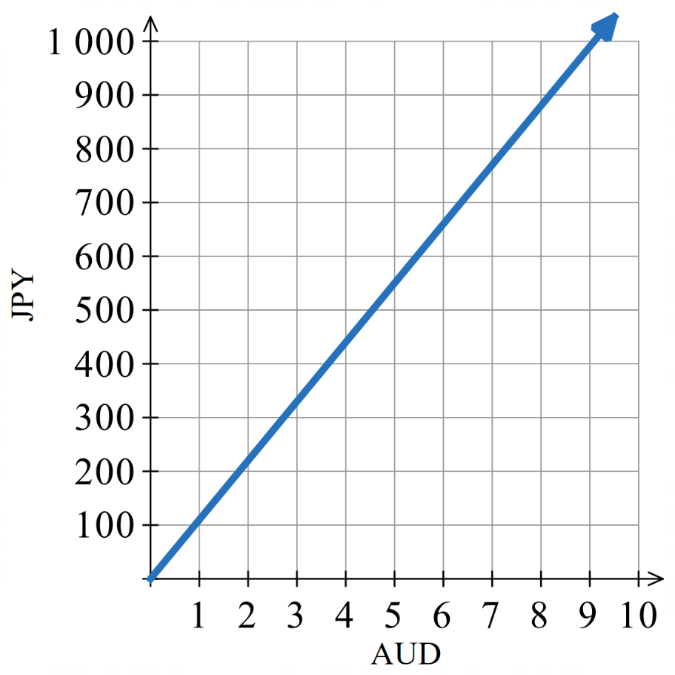

$$JPY=110 AUD$$
How much AUD can you buy with ¥800?

$$\$7.27$$
How much JPY can you buy with $9?

$$¥990$$

Applications of Simultaneous Equations

- Apply Simultaneous Equations to Solve Problems
When a scenario has two variables that aren’t directly related to each other, we need to set up two equations and solve them simultaneously.
- Define the two variables.
- Set up two equations using information from the scenario.
- Solve the two equations simultaneously.
- Answer the question in words.

- Example Apply simultaneous equations to solve problems
The sum of the ages of two children is 17 and the difference in their ages is 5.
If Karla is the older sister of Alice, determine their ages.
1. Let $k$ be Karla’s age. Let $a$ be Alice’s age.  2. $k+a=17$ (1)  $k-a=5$ (2)  3. (1) $+$ (2): $2k=22$  $k=11$ | 3. (cont.) Sub $k=11$ into (1)  $11+b=17$  $b=6$  4. Karla is 11 and Alice is 6

- Guided Practice
The sum of the ages of two children is 24 and the difference between their ages is 8.
If Nikki is the older sister of Travis, determine their ages by setting up and solving a pair of simultaneous equations.
1. Let ……… be ………………………………
Let ……… be ………………………………
2. ……………………………… (1)
……………………………… (2)
3. Solving simultaneously:

4. Answer in words: ………………………………………………………………………………
Nikki: 16, Travis: 8
- Guided Practice
The perimeter of a rectangle is 56 cm. If the length of the rectangle is three times its breadth, determine the dimensions by setting up and solving two simultaneous equations.
1.

2.

3.

4.

Length: 21 cm, Width: 7 cm
Adult concert tickets cost $5 more than child tickets. Two adult tickets and two child tickets cost $70 in total. Find the cost of each ticket.
1.

2.

3.

4.

Child: $15, Adult: $20
- Guided Practice
John buys three daffodils and five petunias from the nursery and pays $25.
Julia buys four daffodils and three petunias for $26.
Determine the cost of each type of flower.

Petunias: $2, Daffodils: $5
Alex buys 4 bolts and 6 washers for $2.20 and Holly spends $1.80 on 3 bolts and 5 washers at the same local hardware store. Determine the costs of each bolt and each washer.

Bolt: $0.10, Washer: $0.30
A scientist mixes a 10% saline solution with a 30% saline solution to produce 200 mL of a 25% saline solution. Find the volume of each solution used.
Hint: Let $x=$ volume of 10% solution in mL,
$y=$ volume of 30% solution in mL.

50 mL of the 10% solution, 150 mL of the 30% solution.

Break-even Analysis

- Break-even Analysis
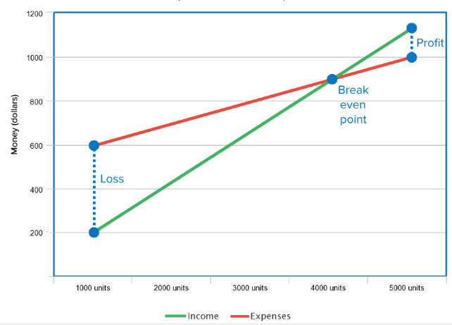
- Break-even analysis is an application of simultaneous equations
where one equation is cost, and the other is revenue.
- The break-even point occurs when costs match income:
  - You make no profit or loss
  - To the left of this point, you operate at a loss
  - To the right of this point, you generate profit

- Example Solve problems using simultaneous linear models
Worked example |  | Your Turn
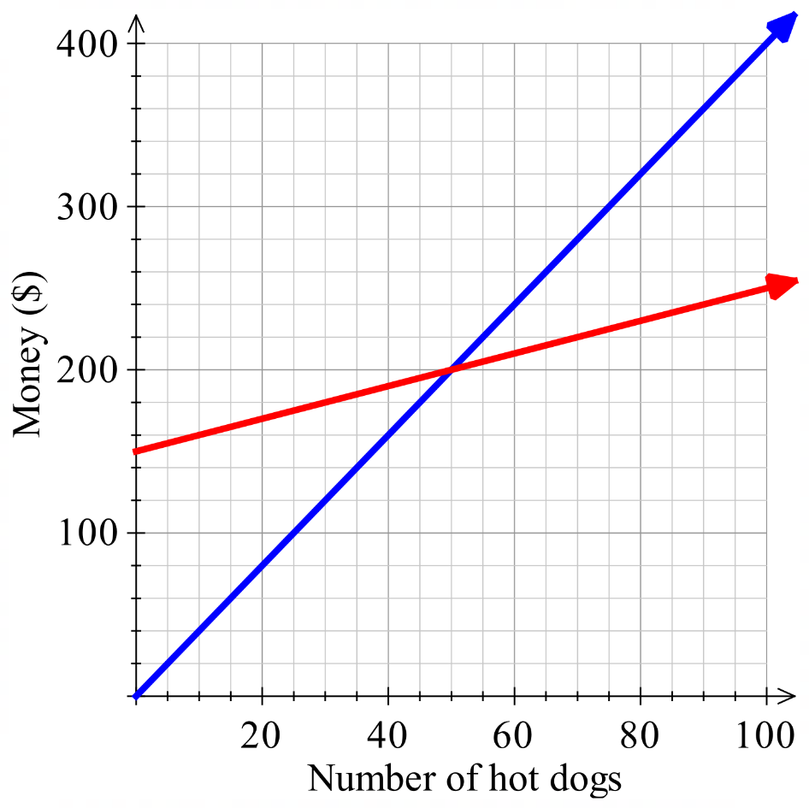  Revenue  Cost  How many hot dogs need to be sold to break even?  Point of intersection at $n=50$ hotdogs.  What is revenue at the break-even point?  Breakeven point is at $200.  What is the profit/loss when 90 hot dogs are sold?  $$At n=90:$$  $$R-C=360-240$$  $=\$120$ profit |  | 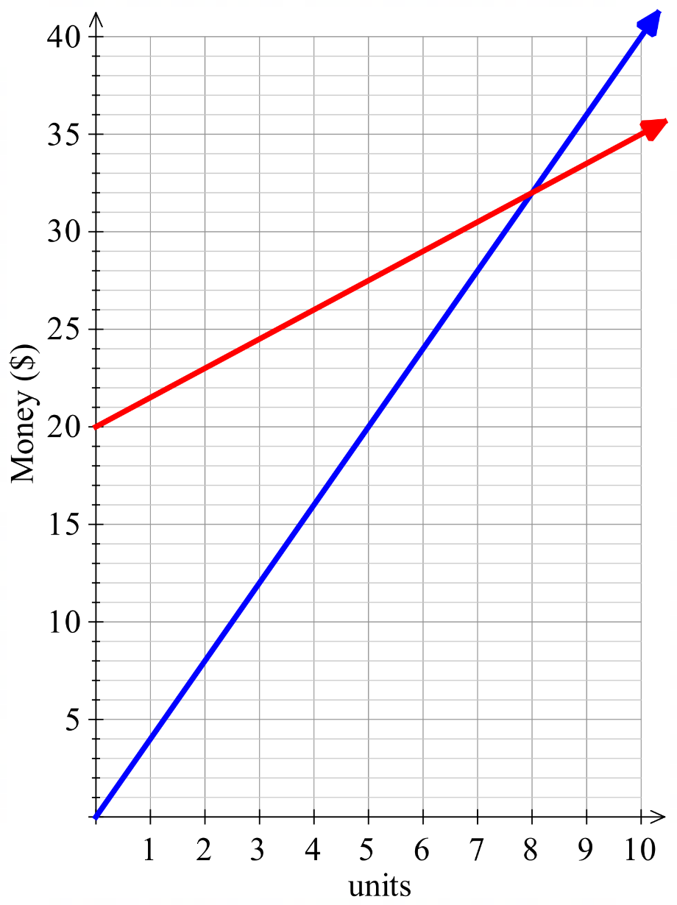  Revenue  Cost  How many units must be sold to break even?  8 units  What is the revenue at the break-even point?  $32  When 4 units are sold, is it profit/loss and by how much?  $10 loss
- Break-even Analysis using Simultaneous Equations
For a revenue equation $R$ and cost equation $C$:
Find Breakeven Point:  Find $n$ when:  $$Revenue=Cost$$ | Find Profit/Loss  $$Profit/Loss=Revenue-Cost$$  Profit is when the difference is positive,  loss is when the difference is negative.

- Example Solve problems using simultaneous linear models
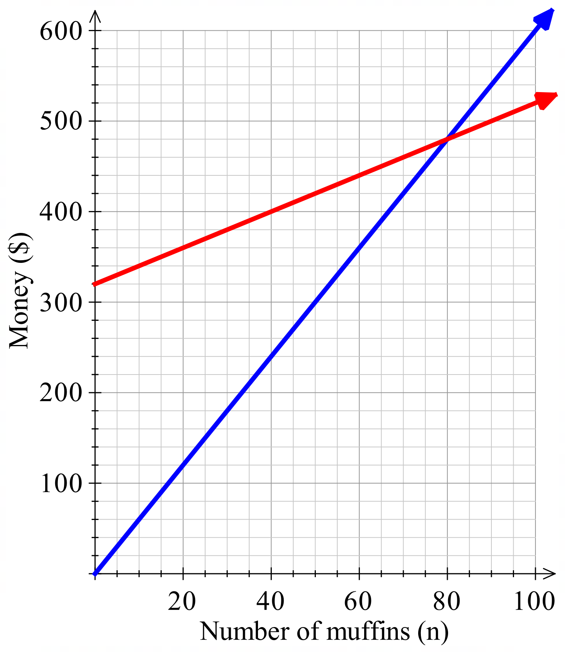
Raf’s Muffin Shop has a fixed cost of $320 per day and a variable production cost of $2 per muffin. The selling price of each muffin is $6.
Revenue
Cost
Write an equation for the cost, $C$, of producing $n$ muffns.
$C=320+2n$
Write an equation for the revenue, $R$,
for the number of muffins sold, $n$.
$R=6n$
Determine the break-even point
algebraically by letting $R=C$
$R=C$  $6n=320+2n$  $4n=320$  $n=80$ | Substitute $n=80$ into $R=6n$  $R=6\left(80\right)$  $=480$
Break-even at 80 muffins, with revenue of $480.

How many muffins must be sold for a profit of $160?
$$R-C=160 \\ 6n-\left(320+2n\right)=160 \\ 4n-320=160 \\ 4n=480 \\ n=120 muffins$$

- Guided Practice
Jenny’s Sandwich Shop had a fixed expense of $1500 per month and a cost of $1.50 per sandwich. The sandwiches were sold for $3.50 each.
- Write linear equations to model the production cost $C$ and revenue $R$ for $n$ sandwiches.
$C=$ ……………… $R=$ …………………
$C=1500+1.5n$, $R=3.5n$
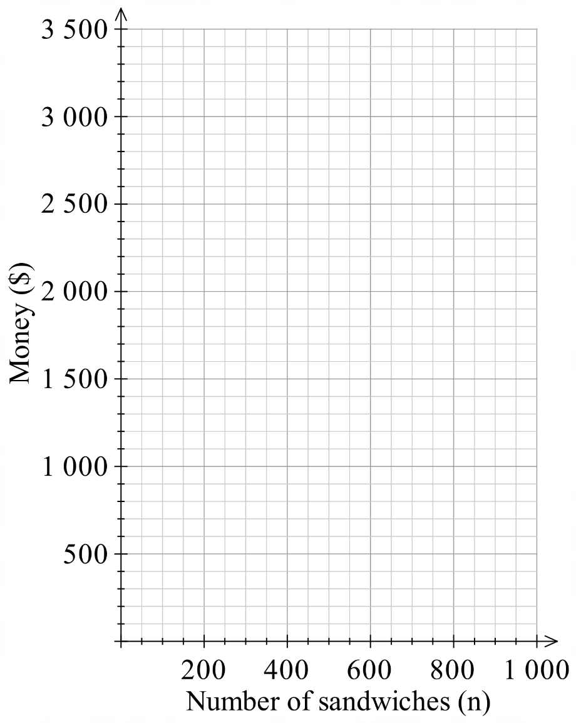
- Graph straight lines modelling the cost and revenue for 0 ≤ $n$ ≤ 1000.
$$n$$ | 0 | 200 | 400
$$R$$

$$n$$ | 0 | 200 | 400
$$C$$

  - Determine the break-even point graphically.

Around 750 sandwiches at $2600
  - Determine algebraically how many muffins need to be sold to break even.

750 sandwiches
  - What is the break-even revenue?

$2625
  - How many sandwiches need to be sold to make a profit of $1000?

1250

Quadratic Modelling

- Quadratic Modelling
Many scenarios can be modelled and solved using a quadratic equation.
  - Let a variable represent the unknown number.
  - Write an equation to describe the problem. (A diagram is helpful).
  - Solve the equation.
  - Check your answer makes sense and has correct units.

- Example Model and solve problems using quadratic equations
The area of a rectangle is fixed at 28 m² and its length is 3 m more than its breadth.
Find the width of the rectangle.
1. Let $x$ be the width.  28 m²  $x+3$ m  $x$ m  2. $x\left(x+3\right)=28$ | 3. $x^{2}+3x=28$  $x^{2}+3x-28=0$  $\left(x+7\right)\left(x-4\right)=0$  $x=-7$or 4  4. The width is 4. $\left(since x>0\right)$

- Guided Practice
- A rectangle has area of 40 m². Its length is 3 m longer than its breadth.
Find the length of the rectangle.

8 m
- A triangle has area of 24 m². Its height is 2 m more than its base.
Calculate the length of the base.

6 m
- A rectangular garden, 10 m by 6 m, is surrounded by a paved path of uniform width.
If the area of the path alone is 80 m², find its width.

2

Solving Problems using Parabolas

